

THE UNIVERSITY OF AZAD JAMMU AND KASHMIR, MUZAFFARABAD
Department of Software Engineering

Submitted to: | Engr. Sidra Rafique
Course Title: | Operating System
Course Code: | CS-2105
Session: | 2024-2028
Lab No: | 04
Roll No: | 2024-SE-15
Submitted By: | Shahzad Ahmed Awan
Submission date: | November 1, 2025

Table of Contents
Lab 04-Understanding Processes and Process Control Block (PCB) 3
1. Objective 3
2. Background 3
3. Task 1 – Process Creation and Observation 3
3.1 Aim 3
3.2 Procedure 3
4. Source Code 4
5. Task 2 – Process States and PCB 4
5.1 Objective 4
5.2 Explanation of Process States 4
5.3 Flowchart Diagram 5
6. Observations 5
7. Conclusion 6
8. Reflection 7

Table of Figures
Figure 1: Source Code for Program with assigned PID 4
Figure 2: Flowchart for the Program 5
Figure 3: Finding the Process in the Task Manager 6
Figure 4: Checking the Process Status through cmd 6
Figure 5: Diagram demonstrating different status a process can have 6

Lab 04-Understanding Processes and Process Control Block (PCB)

1. Objective
The aim of this LAB is to understand how processes work in an operating system, how they are represented through the Process Control Block (PCB), and how to identify process IDs (PIDs) using both Command Prompt (cmd) and Task Manager.
This LAB also explores the different process states through a state transition diagram.

2. Background
A process is a program in execution — an active entity that includes the program code, the program counter, stack, data, and allocated system resources.
The Process Control Block (PCB) is a critical data structure that stores information about each process such as its ID, state, memory details, and CPU registers.
When multiple processes run, the operating system maintains each PCB to manage scheduling, execution, and switching between processes efficiently.

3. Task 1 – Process Creation and Observation

3.1 Aim
To execute a simple C++ program that simulates a process and to observe it in the Task Manager and Command Prompt.

3.2 Procedure
- Open Dev-C++ or any IDE and write the following program.
- Compile and run it to generate the .exe file.
- While the program is running:
  - Open Task Manager → Details tab, locate your program using its Process ID (PID).
  - Or, open Command Prompt and type:
  - tasklist | find "YourProgramName.exe"
- Observe the process entry and its PID appearing in the list.

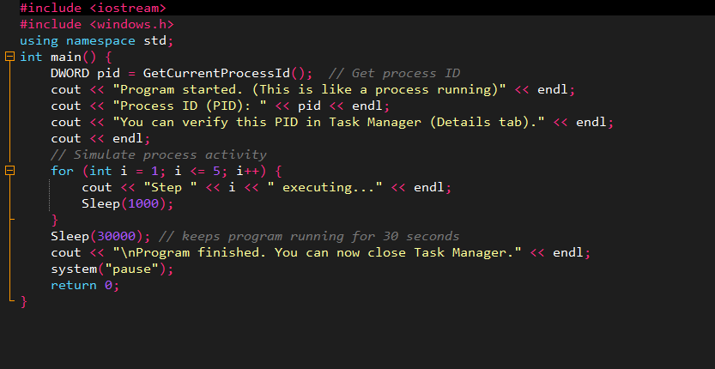
4. Source Code
Figure 1: Source Code for Program with assigned PID

5. Task 2 – Process States and PCB

5.1 Objective
To understand and illustrate different process states in the operating system and their transitions.

5.2 Explanation of Process States
- New: Process creation and resource allocation.
- Ready: Process waiting in the queue for CPU time.
- Running: CPU actively executing the process instructions.
- Waiting/Blocked: Process temporarily halted due to I/O or event wait.
- Terminated: Process has completed execution and its PCB is destroyed.

5.3 Flowchart Diagram
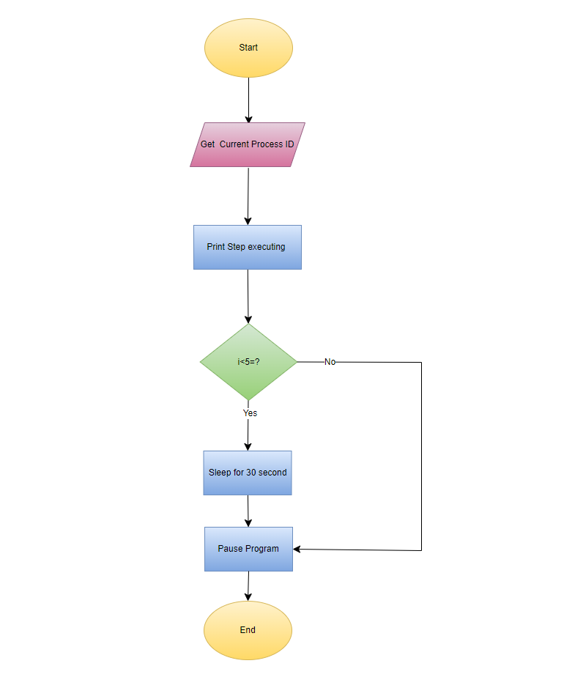
Figure 2: Flowchart for the Program

6. Observations
- Each running application corresponds to a process with a unique Process ID (PID).
- The Task Manager and CMD provide real-time information about process activity.
- During Sleep() calls, CPU usage drops, showing how the scheduler handles idle processes.
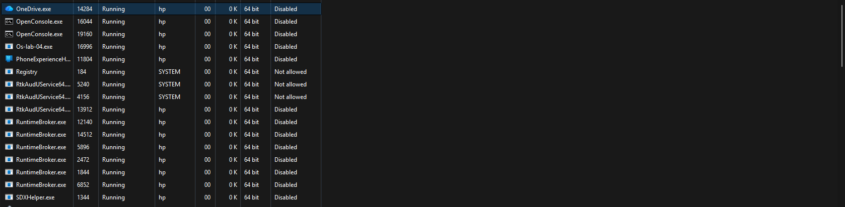
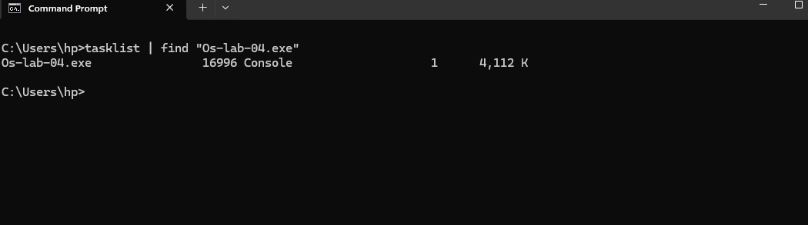
- The PCB maintains vital information allowing the OS to resume or switch between processes efficiently.
Figure 3: Finding the Process in the Task Manager
Figure 4: Checking the Process Status through cmd

7. Conclusion
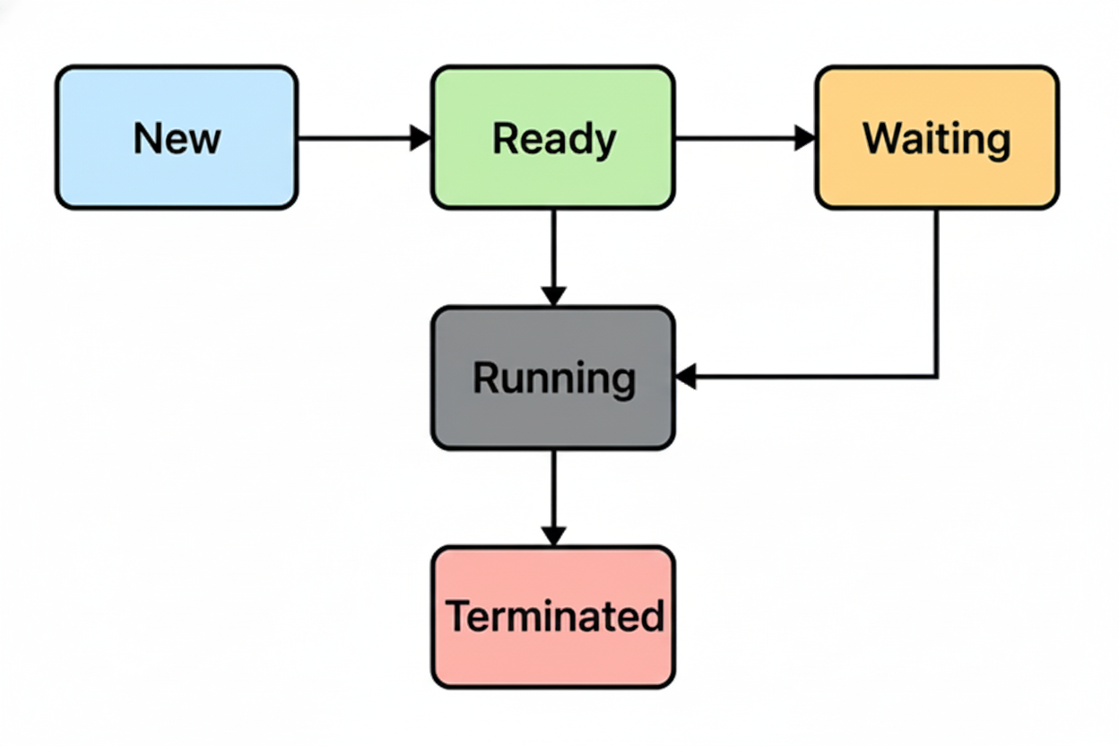
This LAB demonstrated how processes are created, executed, and managed in an operating system.
The experiment provided hands-on experience in identifying process IDs and understanding their behavior in Task Manager.
It also reinforced theoretical knowledge about PCB structure and process state transitions, linking system-level concepts with practical visualization.
Figure 5: Diagram demonstrating different status a process can have

8. Reflection
Through this LAB, I learned and practiced:
- How the operating system assigns and manages Process IDs.
- How to use Command Prompt and Task Manager to monitor running processes.
- The significance of Process Control Blocks (PCB) in maintaining process information.
- How a process moves through different states (New, Ready, Running, Waiting, Terminated).
- How process scheduling and waiting are represented practically using simple code simulation.
This LAB deepened my understanding of real-time process management and how the OS ensures coordination between multiple executing programs.

